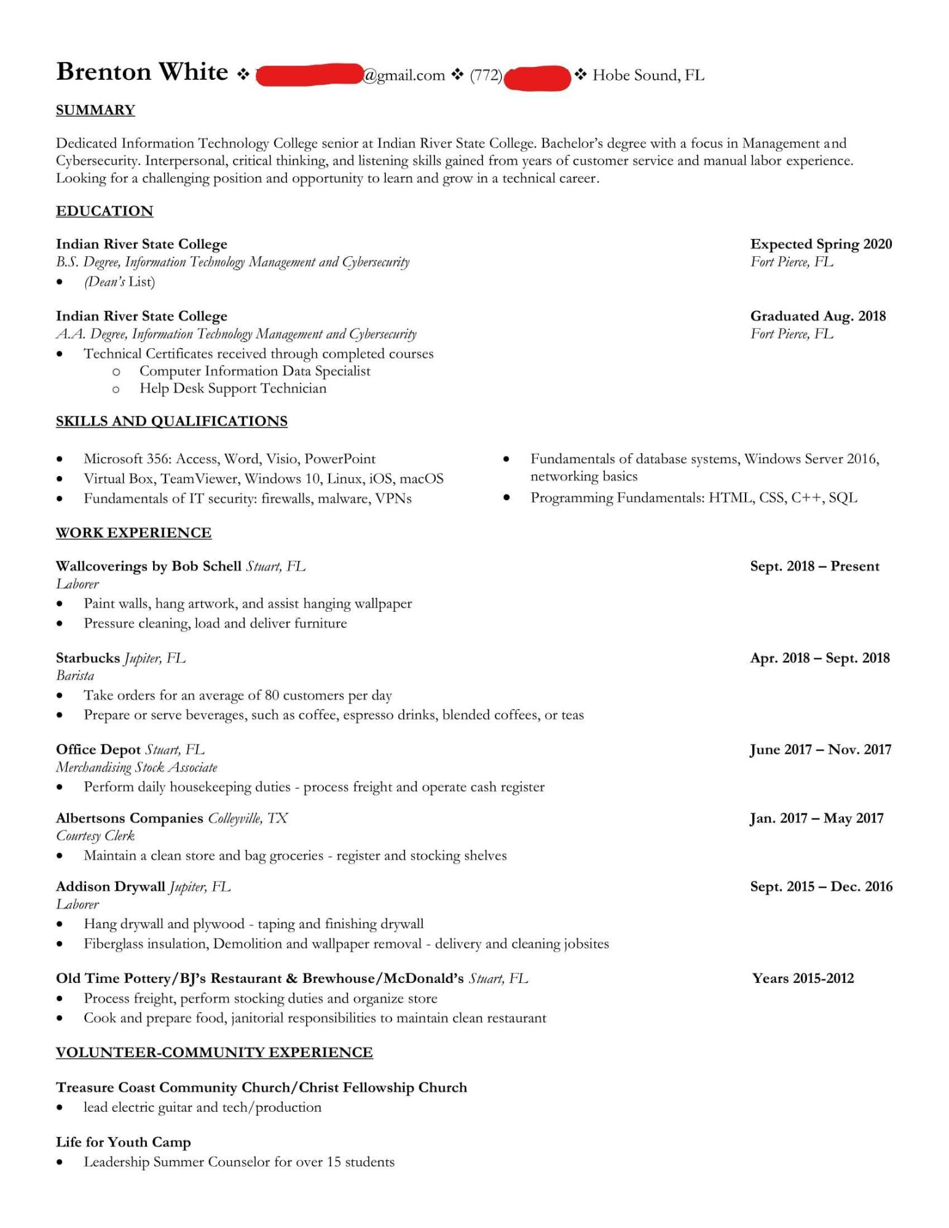
Brenton White
SUMMARY
@gmail.com (772)
Hobe Sound, FL
Dedicated Information Technology College senior at Indian River State College. Bachelor's degree with a focus in Management and Cybersecurity. Interpersonal, critical thinking, and listening skills gained from years of customer service and manual labor experience. Looking for a challenging position and opportunity to learn and grow in a technical career.
EDUCATION
Indian River State College
B.S. Degree, Information Technology Management and Cybersecurity (Dean's List)
Indian River State College
A.A. Degree, Information Technology Management and Cybersecurity
Technical Certificates received through completed courses Computer Information Data Specialist
о
O Help Desk Support Technician
SKILLS AND QUALIFICATIONS
•
Microsoft 356: Access, Word, Visio, PowerPoint
Virtual Box, TeamViewer, Windows 10, Linux, iOS, macOS Fundamentals of IT security: firewalls, malware, VPNs
WORK EXPERIENCE
Wallcoverings by Bob Schell Stuart, FL Laborer
Paint walls, hang artwork, and assist hanging wallpaper
• Pressure cleaning, load and deliver furniture
Starbucks Jupiter, FL
Barista
•
Expected Spring 2020 Fort Pierce, FL
Graduated Aug. 2018 Fort Pierce, FL
Fundamentals of database systems, Windows Server 2016, networking basics
• Programming Fundamentals: HTML, CSS, C++, SQL
Sept. 2018 Present
•
Take orders for an average of 80 customers per day
Prepare or serve beverages, such as coffee, espresso drinks, blended coffees, or teas
Office Depot Stuart, FL
Merchandising Stock Associate
Perform daily housekeeping duties - process freight and operate cash register
Albertsons Companies Colleyville, TX
Courtesy Clerk
· Maintain a clean store and bag groceries - register and stocking shelves
Addison Drywall Jupiter, FL
Laborer
-
Apr. 2018 Sept. 2018
June 2017 - Nov. 2017
Jan. 2017 May 2017
Sept. 2015 Dec. 2016
Hang drywall and plywood - taping and finishing drywall
•
Fiberglass insulation, Demolition and wallpaper removal - delivery and cleaning jobsites
Old Time Pottery/BJ's Restaurant & Brewhouse/McDonald's Stuart, FL
• Process freight, perform stocking duties and organize store
•
Cook and prepare food, janitorial responsibilities to maintain clean restaurant
VOLUNTEER-COMMUNITY EXPERIENCE
Treasure Coast Community Church/Christ Fellowship Church
•
lead electric guitar and tech/production
Life for Youth Camp
•
Leadership Summer Counselor for over 15 students
Years 2015-2012

